Name: Divit Patidar

Phone Number: 7680857707

Mail id: [divit.patidar@gmail.com](mailto:divit.patidar@gmail.com)

Linked In : https://www.linkedin.com/in/divit-patidar-6732a61b0/

1. **Creating a Database & a Table (Transactions & items);**

* **Made 2 primary keys in both the tables;**
* **Reason for transactions table:** Needed a column to uniquely identify each record.
* **Reason for items table:** I could use Composite key (multiple primary keys) for the purpose of combining item_id & store_id and use those in the transactions table by referencing them as foreign key, but that wasn’t possible due to a reason because the values of store_id & item_id in the transaction tables weren’t matching the values with the items table as the table given was incomplete so I wasn’t allowed to add values in the transactions table which weren’t the primary key values in the items table so I had to make a new column “id”.

**CREATE TABLE transactions(**

**id int NOT NULL,**

**buyer_id int NOT NULL,**

**purchase_time datetime NOT NULL,**

**refund_time datetime,**

**item_id varchar(255) NOT NULL,**

**store_id varchar(255) NOT NULL,**

**gross_transaction_value INT NOT NULL,**

**PRIMARY KEY(id),**

**foreign key(id) REFERENCES items(id)**

**);**

**CREATE TABLE items(**

**id int NOT NULL,**

**item_id varchar(255) NOT NULL,**

**store_id varchar(255) NOT NULL,**

**item_category varchar(255),**

**item_name varchar(255),**

**primary key(id)**

**);**

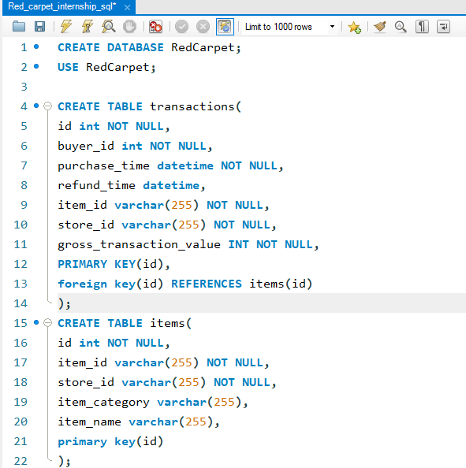

1. **Showing the Table type (transactions & items);**

**a). Transactions:**

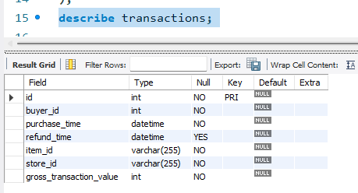

**b). Items:**

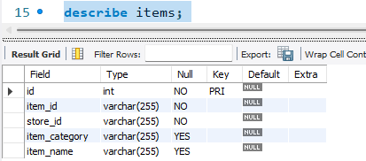

**C). Adding values in items & transactions table;**

**a). items;**

**Insert into items values(1,'a', 'a1', 'pants', 'demipants'), (2,'a', 'a2','tops', 'blouse'), (3,'f', 'f1', 'table', 'coffee table'), (4,'f', 'f5', 'chair', 'lounge chair'), (5,'f', 'f6', 'chair', 'armchair'), (6,'d', 'd2', 'jewellery', 'bracelet') , (7,'b', 'b4', 'earphone', 'airpods');**

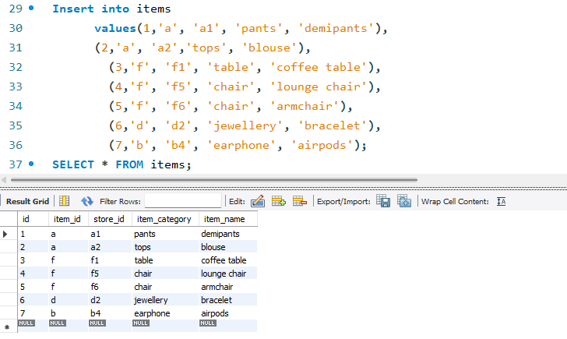

**b). Transactions;**

**insert into transactions**

**(id,buyer_id, purchase_time,store_id,item_id, gross_transaction_value)**

**values(1, 3, '2019-09-29 21:19:06.544', 'a', 'a1', 58),(4, 2, '2020-04-30 21:19:06.544', 'd', 'd3', 250),**

**(5, 1, '2020-10-22 22:20:06.531', 'f', 'f2', 91), (6, 8, '2020-04-16 12:10:22.214', 'e', 'e7', 24);**

**insert into transactions**

**values(2, 12, '2019-12-10 20:10:14.324','2019-12-15 23:19:06.544', 'a', 'b2', 475),**

**(3, 3, '2020-09-01 23:59:46.531','2020-09-02 23:59:46.53', 'f', '19', 33),**

**(7, 5, '2019-9-23 12:09:35.542', '2019-09-27 02:55:02.114', 'g', 'g6', 61);**

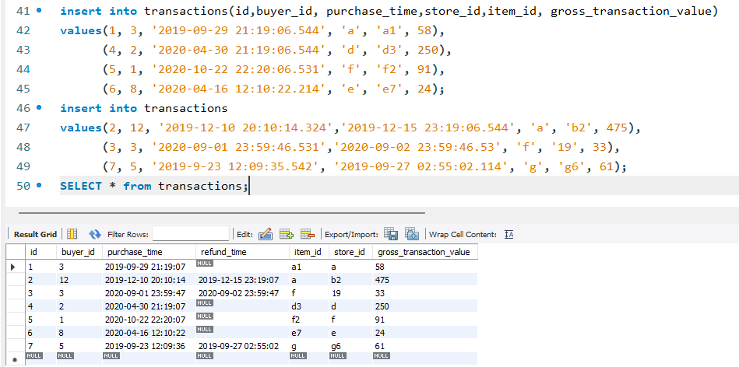

**Q). Solving the Questions.**

**1. What is the count of purchases per month (excluding refunded purchases)?**

**>**

**SELECT item_id, COUNT(item_id) count, MONTH(purchase_time) month**

**FROM transactions**

**GROUP BY MONTH(purchase_time);**

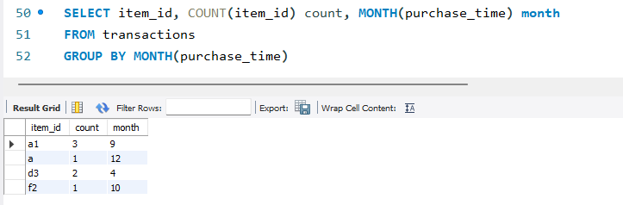

**2.How many stores receive at least 5 orders/ transactions in October?**

**> answer is 0 because if we see the orders in that month, has just 1 order**

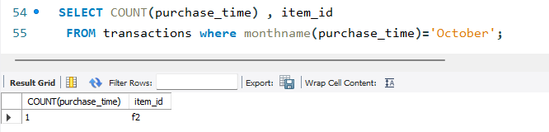

**3. For each store, what is the shortest interval (in min) from purchase to refund time?**

**> Couldn’t solve this question sorry.**

**4. What is the gross_transaction_value of every store’s first order?**

**>**

**select store_id, purchase_time,gross_transaction_value**

**FROM Transactions**

**ORDER By purchase_time;**

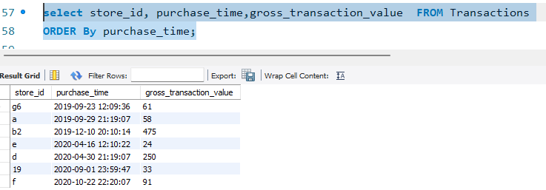

**5. What is the most popular item name that buyers order on their first purchase?**

**>**

**select buyer_id, COUNT(item_id)**

**FROM transactions**

**GROUP BY item_id LIMIT 3;**

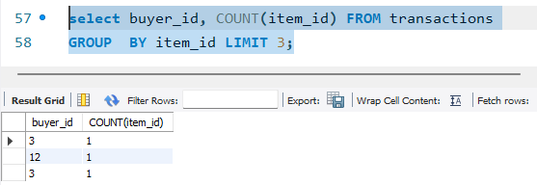

**6. Create a flag in the transaction items table indicating whether the refund can be processed or not. The condition for a refund to be processed is that it has to happen within 72 of Purchase time. Expected**

**> SELECT \***

**FROM transactions**

**WHERE purchase_time >= refund_time - INTERVAL 3 DAY**

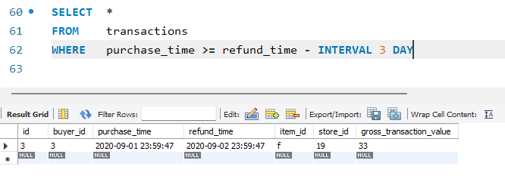

**7. Create a rank by buyer_id column in the transaction items table and filter for only the second purchase per buyer.**

**>**

**SELECT id, COUNT(buyer_id) all_orders FROM transactions**

**GROUP by buyer_id having count(buyer_id) = 2**

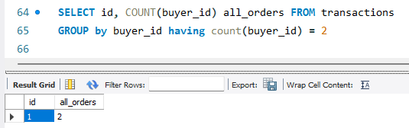

**8). How will you find the second transaction time per buyer (don’t use min/max; assume there were more transactions per buyer in the table).**

**>**

**SELECT id, COUNT(buyer_id), purchase_time, COUNT(buyer_id) FROM transactions**

**GROUP by buyer_id HAVING COUNT(buyer_id)=2;**

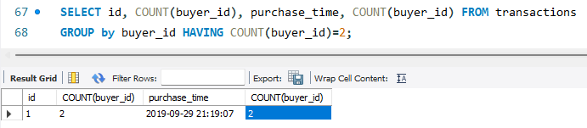

* **Thank You**